**Understanding Design Patterns in React: Optimizing Scalability and Maintainability**

[[Adarsh Rai](https://medium.com/@adarshrai3011?source=post_page-----e1dbbbb205e8--------------------------------)](https://medium.com/@adarshrai3011?source=post_page-----e1dbbbb205e8--------------------------------)

[Adarsh Rai](https://medium.com/@adarshrai3011?source=post_page-----e1dbbbb205e8--------------------------------)

·

Follow

12 min read

·

Dec 14

23



React stands as one of the most widely adopted JavaScript libraries for crafting user interfaces, owing to its versatile and flexible nature. Its widespread acclaim is attributed to various factors, including its lack of strict opinions. The library’s strengths lie in its reusable component structure, robust developer tools, and a vast ecosystem. Moreover, beyond these attributes and the strong community backing, React further streamlines development by integrating and implementing a range of well-established design patterns.

Before delving into the specifics of React’s design patterns, it’s crucial to grasp their essence and significance. In essence, design patterns refer to recurring solutions for common development challenges. These patterns act as foundational templates, facilitating the construction of diverse functionalities in accordance with specified requirements, while adhering to industry best practices. By leveraging these patterns, developers can significantly economize development time and effort, relying on tried-and-tested solutions and standardized methodologies for known problems.

Let’s embark on an exploration of these design patterns within React!

**Conditional Rendering**

Conditional Rendering stands out as one of the fundamental and extensively utilized patterns within React components. Its concept revolves around selectively rendering JSX code based on specific conditions, a practice commonly known as conditional rendering. For instance, displaying a “Log In” button for unauthenticated users and a “Log Out” button for signed-in users illustrates this pattern.



**Conditional Rendering Example**

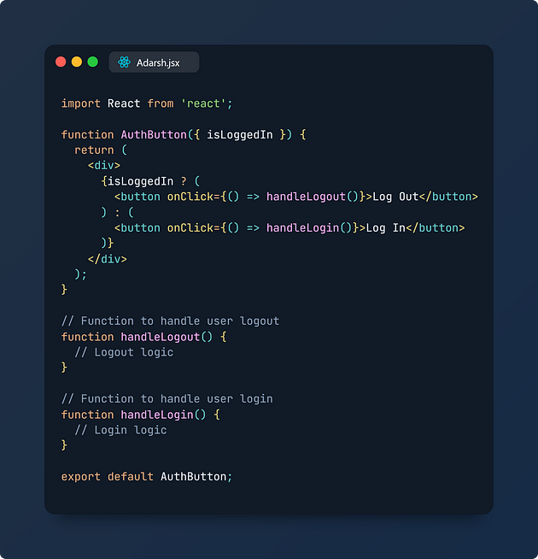

In this example, the AuthButton component employs conditional rendering to showcase different buttons based on the isLoggedIn prop. If the user is logged in (isLoggedIn is true), the component renders a "Log Out" button with the respective logic. Conversely, for unauthenticated users (isLoggedIn is false), it displays a "Log In" button triggering the login functionality upon click.

This pattern allows React components to dynamically adjust their output based on changing conditions, ensuring a tailored user experience. Typically, conditional rendering in React involves using the logical && operator or the ternary operator (? :), enabling developers to craft dynamic interfaces based on various states or user interactions. In more complex scenarios, conditional rendering might also involve using constructs like if statements, switch cases, or object literals for intricate logic execution.

Understanding and employing conditional rendering is foundational in React development, enabling developers to create adaptable and user-centric interfaces.

**React Hooks: Simplifying Logic Reusability**

React hooks have revolutionized functional components by granting direct access to fundamental React functionalities like props, state, context, refs, and lifecycle methods. While leveraging standard hooks like useEffect and useState suffices for many scenarios, the introduction of custom hooks takes it a step further. Let’s explore the advantages of integrating custom hooks into our codebase. Imagine a scenario where you’ve crafted a piece of logic within a component utilizing basic hooks like useEffect and useState. Later on, the same logic becomes necessary in a new component. While copying and pasting might seem convenient initially, custom hooks offer a more engaging alternative. By abstracting commonly used logic into a hook, it promotes cleaner, reusable, and easily maintainable code.



**Example: Utilizing a Custom Fetch Hook**

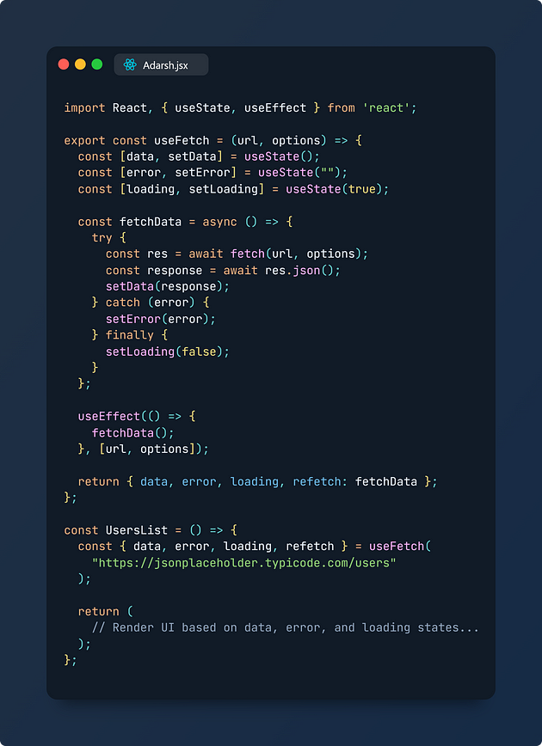

In this beginner-friendly example, the useFetch custom hook abstracts the logic for making API calls. The UsersList component utilizes this hook to fetch user data from an API endpoint, encapsulating data handling and loading/error states within the hook. This promotes code cleanliness, reusability, and maintainability by centralizing common functionalities into custom hooks.

**Other Possible Use Cases for Custom Hooks:**

* Retrieving window dimensions
* Managing local storage operations (reading and writing)
* Implementing toggling mechanisms for boolean states, and more.

Custom hooks provide a powerful toolset for encapsulating and reusing functionalities across different components, enhancing code modularity and facilitating the creation of cleaner and more maintainable React applications.

**Provider Pattern: Simplifying Data Propagation**

One of the primary challenges faced by React developers is “Prop drilling,” a situation where data (props) is passed down through multiple components until it reaches the component where it’s required. This often results in a convoluted chain of data passing, particularly problematic when data needs to reach deeply nested components within the component tree.



To alleviate this issue, the Provider pattern emerges as a solution. It allows storing data, either global or shareable in nature, within a centralized location. This eliminates the need for prop drilling, enabling the Context Provider/Store to directly furnish this data to any component that requires it. React’s native Context API aligns with this approach, and several other libraries like react-redux, flux, MobX, etc., also adopt this pattern.

**Implementing a Theme Context Provider**

Consider implementing a light/dark theme within an application. Without the Provider pattern, it might involve cumbersome prop drilling as shown below:

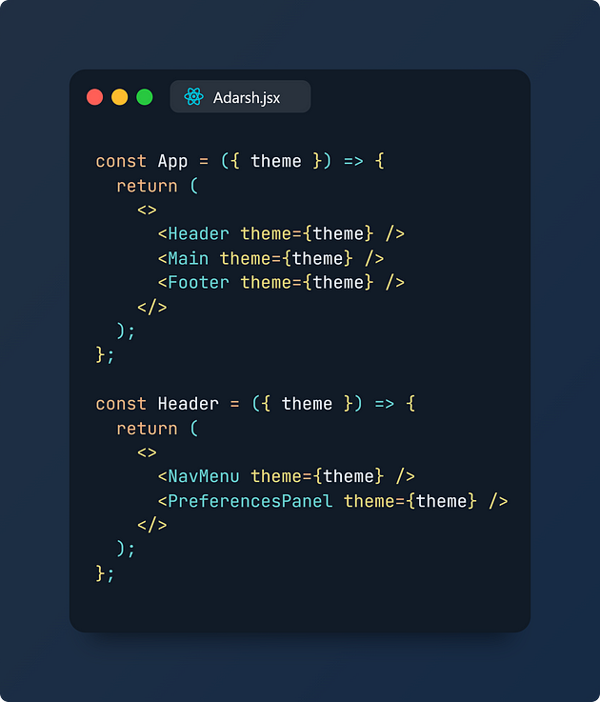

Now, let’s explore how integrating the Context API simplifies this process:

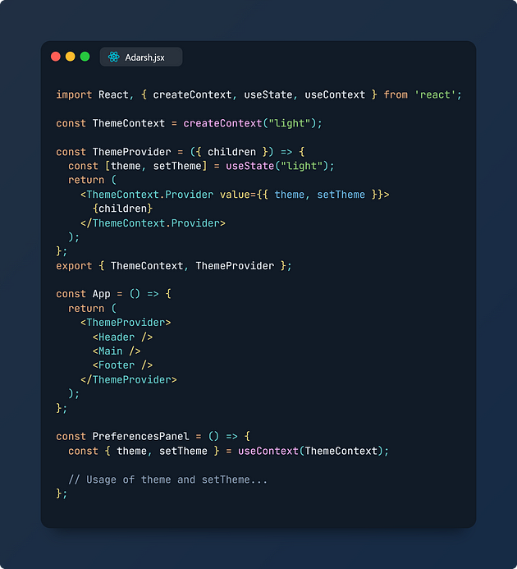

This approach using Context API simplifies the management of themes across various components, avoiding the need for excessive prop drilling. Similarly, the Provider pattern finds application in managing authentication states, handling user locale/language preferences, and more.

The Provider pattern enhances React application development by centralizing data management and facilitating seamless data access across multiple components.

**Higher Order Components (HOCs): Reusing Component Logic**

HOCs within React represent an advanced technique for efficiently reusing logic across components. This pattern stems from React’s compositional nature, embodying the “Don’t Repeat Yourself” (DRY) principle in programming. Functioning akin to higher-order functions in JavaScript, HOCs are pure functions that accept a component as an argument and return an enhanced version of that component. This concept aligns with React’s emphasis on composition over inheritance in functional components. Real-world implementations of HOCs can be seen in popular libraries like react-redux, react-router, material-ui, etc.

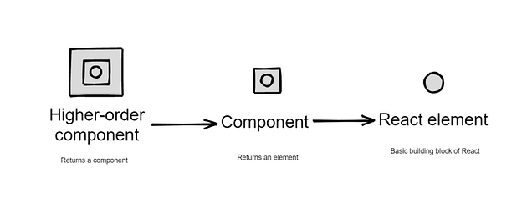

**Example: Utilizing an API Feedback HOC**

Consider a scenario where you’re handling API fetch states (loading, error, data availability) within a component:

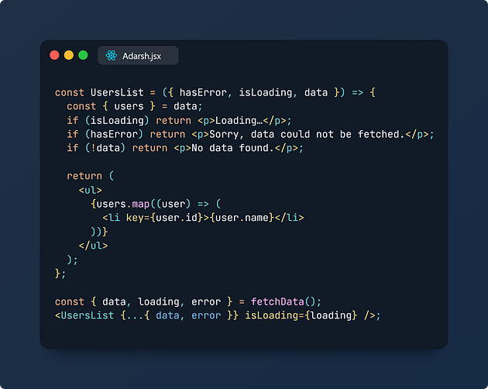

To reuse this API fetch logic across multiple components, we can create an HOC:

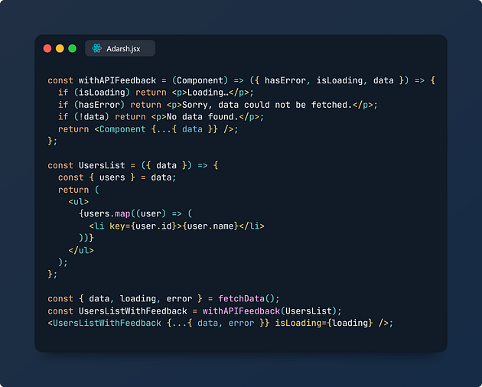

This HOC, withAPIFeedback, encapsulates the logic for handling various API fetch states. By wrapping a component (e.g., UsersList) with this HOC, it augments the component with consistent API feedback logic, promoting code reusability and minimizing redundancy across the application.

**Possible Use Cases for HOCs:**

* Implementing logging mechanisms across multiple components.
* Managing authorization mechanisms, ensuring consistent access controls throughout the application, and more.

**Presentational & Container Components Pattern: Separating Appearance from Logic**

This methodology involves categorizing components into two distinct types with different roles:

Presentation Components: These components, often stateless and functional, are solely focused on the visual presentation. They handle how things look without any ties to the application’s internal logic. Their primary role is to display data.

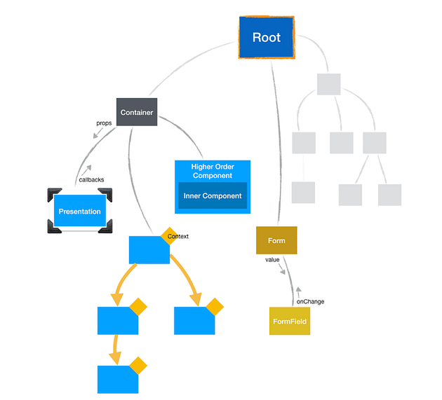

Container Components: Unlike presentation components, container components are responsible for handling the application’s logic and functionality. They encapsulate stateful logic, side effects, and manage the presentation components.

By adopting this approach, developers achieve a better separation of concerns. It prevents the creation of monolithic components that handle both rendering and logical states, promoting a cleaner and more organized codebase. Additionally, it facilitates enhanced reusability of Presentation components due to their lack of dependencies, enabling them to be easily employed in various scenarios.

**Example: Implementing Presentational & Container Components**

Consider a scenario where you’re rendering a list of products:

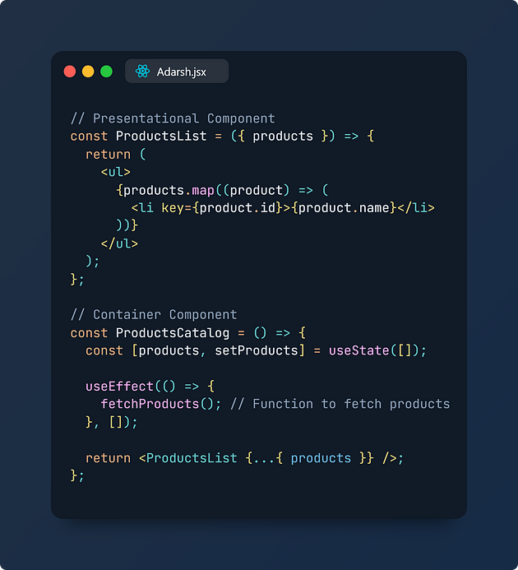

In this example, ProductsList serves as a Presentational component that simply renders the list of products. On the other hand, ProductsCatalog acts as a Container component. It manages the state (via useState), fetches the products (using useEffect), and passes the retrieved data to the Presentational component ProductsList.

Adhering to this pattern encourages developers to create stateless components whenever possible, fostering a clear hierarchy where parent components manage most of the state while delegating visual rendering to stateless child components.

This methodology promotes maintainability, scalability, and component reusability, enhancing the overall robustness and organization of React applications.

**Controlled & Uncontrolled Components in React Forms**

React applications commonly utilize web forms, and managing form data can be approached in two ways within React components: Controlled Components and Uncontrolled Components.

Controlled Components: These components manage form data using React state within the component itself. Values of form elements (like inputs) are controlled and maintained by React state.

Uncontrolled Components: In contrast, uncontrolled components let the DOM handle form data internally within the component, rather than being controlled by React state. Here, the term “uncontrolled” implies that these components rely on traditional DOM mutations rather than React state management.

**Example: Uncontrolled Component**

Consider an example of an uncontrolled component:

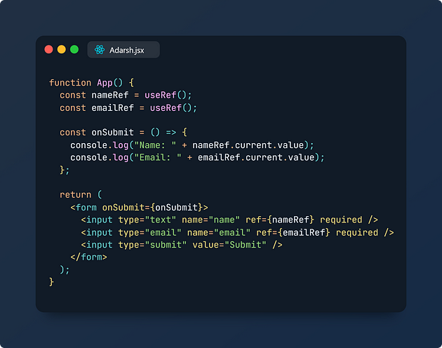

In this example, refs (nameRef and emailRef) are used to access the input values directly. These uncontrolled components do not manage their state via React but rather depend on direct DOM access.

**Example: Controlled Component**

Now, let’s see the controlled version of the same form:

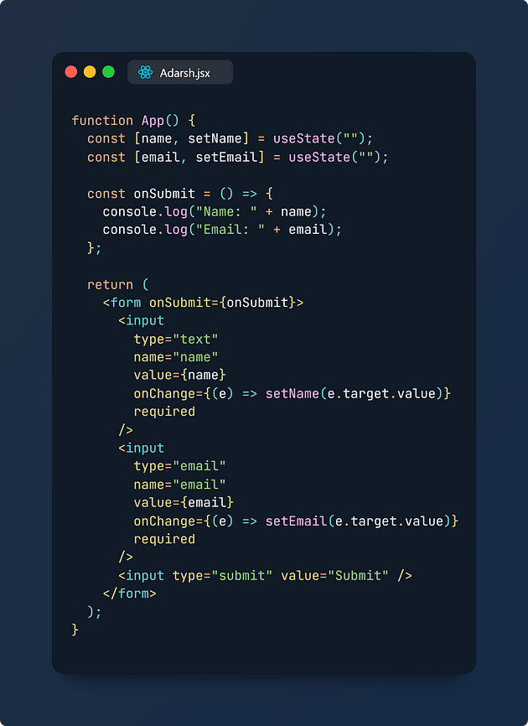

In this controlled component example, the input values are entirely controlled by React state (name and email), and their values are updated via useState and onChange event handlers.



Both approaches have their use cases: uncontrolled components might be preferable for simple UI feedback, while controlled components are recommended for complex logic that requires precise control over form data using React state.

**Render Props Pattern: Sharing Component Logic**

The Render Props technique, as per React’s official documentation, involves utilizing a prop whose value is a function to share code between components. Similar to Higher Order Components (HOCs), Render Props serve the purpose of dealing with shared stateful logic and concerns across components.

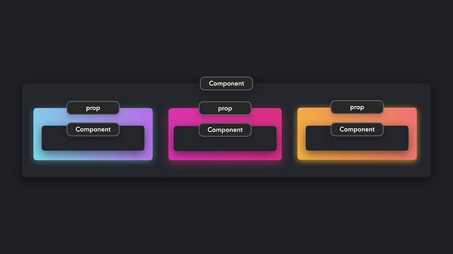

In this pattern, a component implementing the Render Props pattern accepts a function returning a React Element as a prop and invokes it instead of using its internal rendering logic. This approach promotes reusable and adaptable component logic.

**Example: Implementing Render Props for Product Listing**

Consider a scenario where you have a list of products to be rendered in different areas of your application. The logic for fetching and displaying these products might be the same, but the UI representation could vary. Using the Render Props pattern can help make this logic reusable:

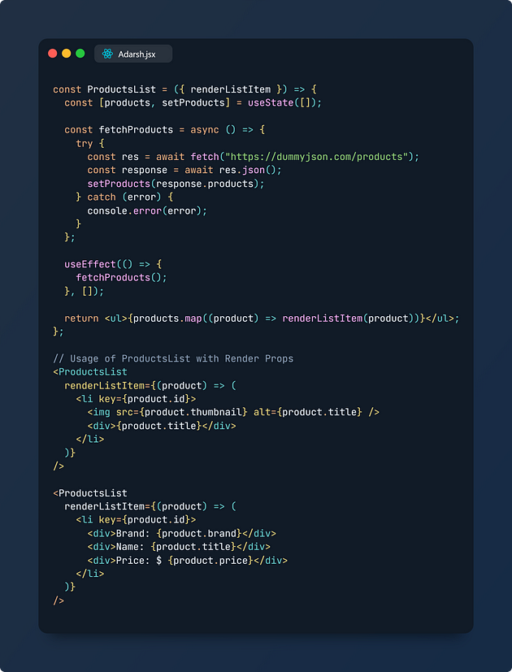

In this example, ProductsList component accepts a renderListItem prop, which is a function defining how each product should be rendered. This allows flexibility in rendering different representations of products across various parts of the application.

The Render Props pattern facilitates reusability and flexibility in sharing component logic across different scenarios within React components. Libraries such as React Router, Formik, and Downshift make use of this pattern for adaptable and reusable functionalities.

**Compound Components Pattern: Collaborative Component Interaction**

Compound components present an advanced React container pattern that facilitates multiple components to seamlessly share states and manage logic together. This pattern offers an efficient and straightforward means for parent components and their children to interact and share states implicitly. It’s a powerful approach when creating declarative user interfaces in React applications. Notably, it’s utilized in renowned design libraries like Ant Design and Material UI.



To grasp this concept better, let’s consider the conventional behavior of HTML select and option elements. Both work cohesively to provide a dropdown form field. The select element, without explicitly declaring its state, manages its state implicitly with the options elements. Similarly, in React, the Compound Components pattern uses mechanisms like the Context API to effortlessly manage and share state between parent and child components.

**Example: Implementing a Tab Component as Compound Components**

Let’s create a Tab component using Compound Components. Tabs usually consist of a list of selectable tabs linked to respective content sections. Only one tab is active at a time, displaying its corresponding content:

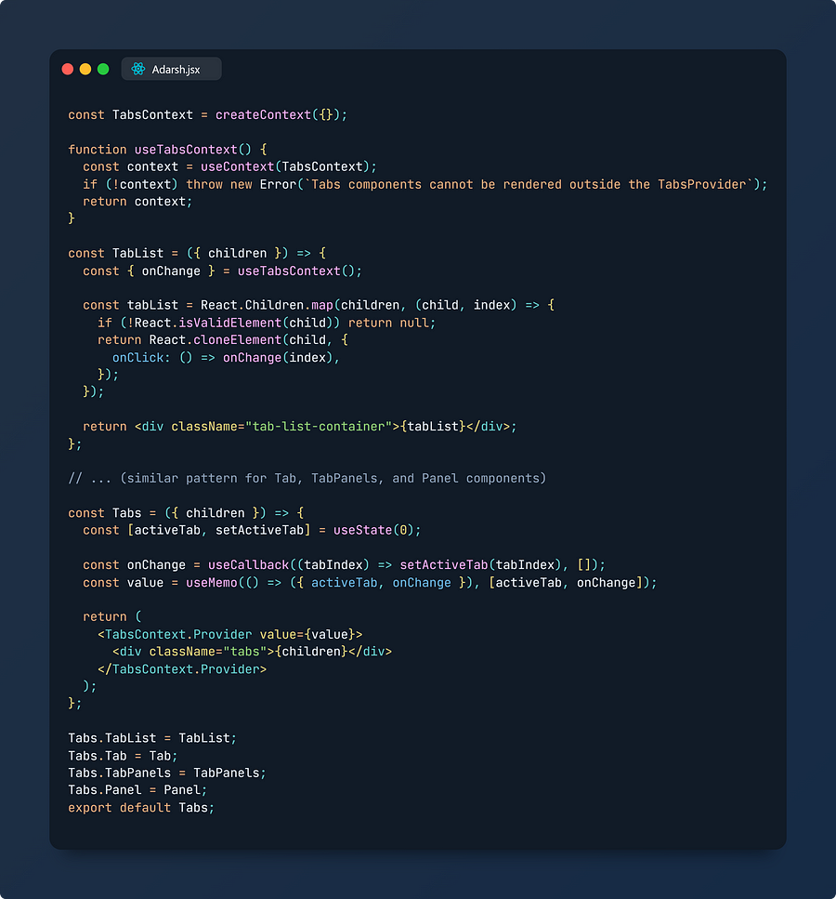

**Usage of Compound Components — Tabs:**

Now, you can employ this Tab component in your application:

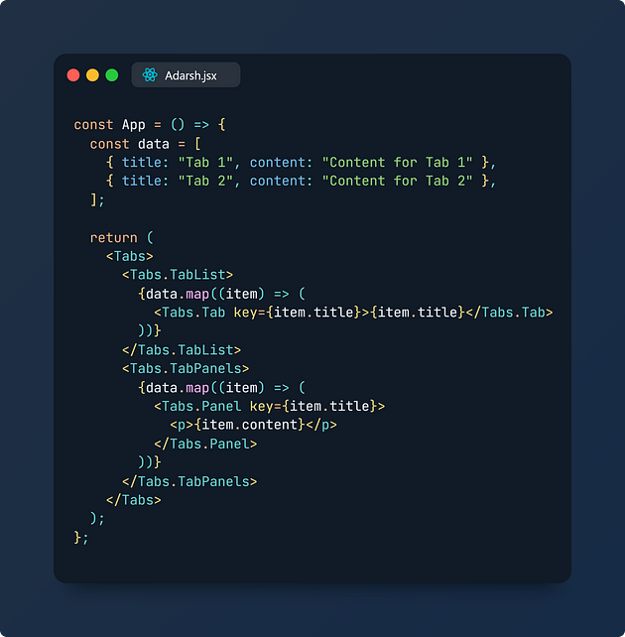

This Compound Components pattern allows you to create reusable and interconnected components like tabs, menus, tables, or accordions with distinct sections, enhancing your React application’s flexibility and organization.

**Layout Components Pattern: Streamlining Common Page Elements**

In React applications or websites, several pages often share identical elements like a navigation bar or a footer. Instead of importing and including these components separately in each page, creating a layout component proves to be more efficient. Layout components enable the seamless sharing of common sections across multiple pages, effectively defining the application’s overall structure and appearance.

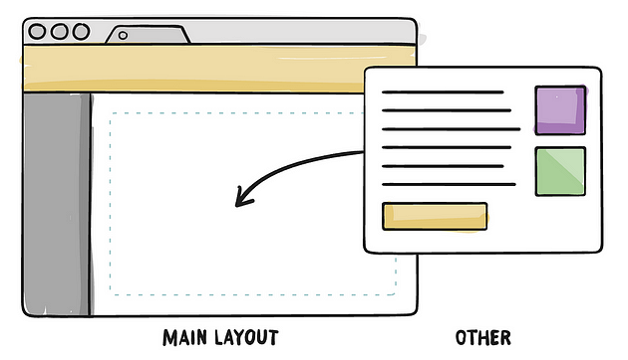

**Example: Creating a Basic Layout Component**

Let’s explore a simple example of a Layout component that integrates a common Header and Footer across various pages:

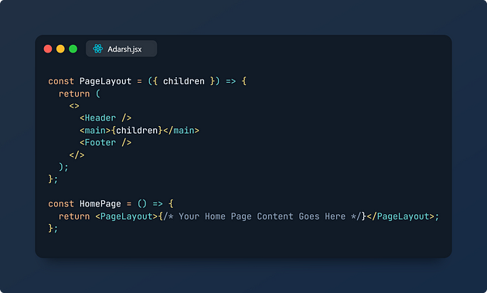

In this example, the PageLayout component encapsulates the layout structure by incorporating a common Header and Footer, allowing the insertion of dynamic content between them via the children prop. By utilizing this pattern, you can define once and reuse this layout structure across multiple pages, enhancing code reusability and streamlining the development process.

Utilizing layout components adheres to a robust coding practice, enabling developers to write code once and utilize it efficiently across various parts of the application. For instance, layouts based on grid systems or flexbox models can be easily standardized and reused, optimizing the development workflow in React applications.

**Conclusion**

In the realm of React development, employing diverse design patterns and techniques empowers developers to architect scalable, maintainable, and efficient applications. Each method offers unique advantages, aiding in code organization, reusability, and enhancing overall application robustness.

Understanding Design Patterns in React

Design patterns serve as blueprints for solving common development problems. They streamline the development process by providing standardized solutions while adhering to best practices. Incorporating design patterns in React applications not only saves time but also ensures code maintainability and readability.

Key Design Patterns Explored:

* Conditional Rendering: Allows dynamic rendering of components based on specific conditions, simplifying the display of elements as per certain states or data.
* Custom Hooks: Offers a way to abstract and reuse logic across components, enhancing code cleanliness, reusability, and maintainability.
* Provider Pattern: Facilitates centralized data management, reducing prop drilling and enhancing state sharing across components.
* Higher Order Components (HOCs): Enables the reuse of logic across multiple components, promoting the principle of composition over inheritance.
* Presentational & Container Components Pattern: Provides clear separation between components responsible for UI presentation and those managing logic, enhancing code readability and maintainability.
* Controlled & Uncontrolled Component Pattern: Offers approaches for handling form data, allowing explicit control over form elements or letting the DOM manage the data.
* Render Props Pattern: Aids in sharing code between components using a function prop, promoting flexibility and reusability.
* Compound Components Pattern: Facilitates collaborative interaction among multiple components, allowing them to share states and logic efficiently.
* Layout Components Pattern: Streamlines common page elements across multiple pages, ensuring consistent layout structures with shared components.

Adopting these patterns strategically within React applications can significantly elevate code quality, fostering scalability, maintainability, and efficient collaboration among developers.

By comprehending and effectively utilizing these design patterns, developers can architect React applications that are not just robust and efficient but also scalable and adaptable to evolving project requirements.

These design patterns in React serve as invaluable tools in the hands of developers, offering versatile solutions to various development challenges and significantly contributing to the success of React-based projects.